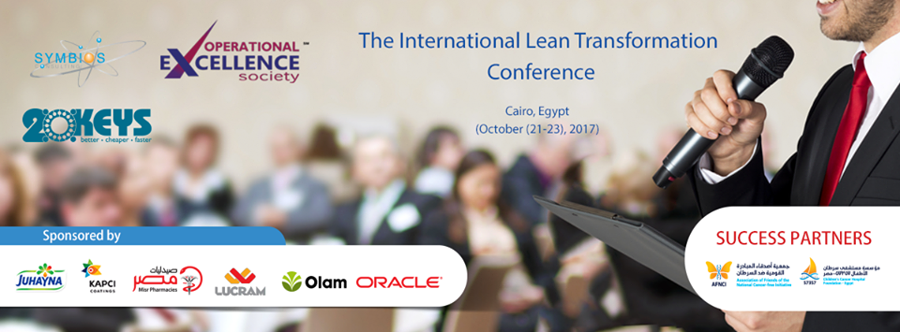

The Lean Transformation Conference event report
The lean transformation is an international +affair that take place in various countries in the world since 1992.This year the conference is taking place in Egypt on the 21st of October in Kempinski Royal Maxim Hotel.
The conference featured guests from Bulgaria, Egypt, Japan, Mozambique, South Africa and Tanzania as well as study tours on the 22nd and 23rd of October inside factories that have successfully implemented lean production.

Pre event phase:
Before the event started we assured that we have social media coverage on different social media plat forms a budget of 700 USD was spent on social media.
Facebook: an event page has been especially created for the conference as well as more than 20 posts that talks about the speakers and their profiles and that on the Facebook page
Linked in: we’ve posted 10 posts introduce the speakers and the profiles, also the posts were about lean and lean six sigma.
Linked in link
Instagram: with 18 posts on

Instagram that either talk about the speakers or create awareness about the conference.
Event Phase
Conference
Speakers: 13 speakers from various countries Bulgaria, Egypt, Japan, Mozambique, South Africa and Tanzania
Eng.Shereen Mosallam: (Egypt) Symbios Consulting Group Leader Egypt, UAE, KSA Member of the OPEX Global Society Ex Director Supply Chain Council Chapter for the Middle East and North Africa.
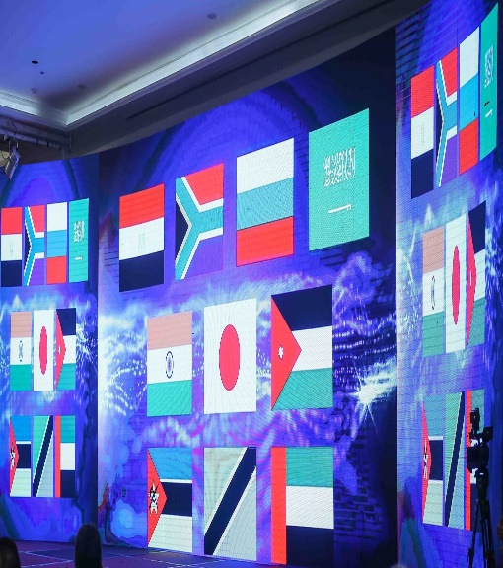
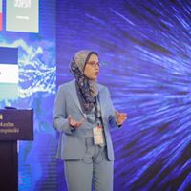

Page 1

Dr. Yoshiyuki Kobayashi:
President of PPORF Development Institute Inc.
Mr. James Ferns: 20 Keys Facilitator and CI leader Novoz Horizontes Mozambique
Mr. Mohamed Abdellatif: leads the Boost project management in Cairo and the North Middle East Region as Internal Consultant of Continuous Improvement and Industrial Development.
Mr. Hamdy Nasser: MENA Senior Productivity Manager, PepsiCo Egypt
Toshko Petkov Partner, Business Consulting Next Consult Bulgaria
Sherif soliman :Operations Manager and Production and improvement manager at Leoni company
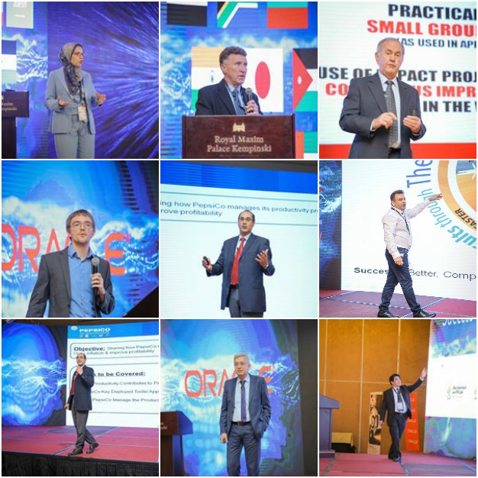
Mr. ROLAND RÖHRS was the CEO of Dorbyl Limited and the Managing Director of Organisation Development International (ODI) and remains the non-executive chairman
Mr. James Ferns 20 Keys Facilitator and CI leader Novoz Horizontes
Eng. Mohamed El Sayed: Supply Chain Manager, KAPCI Coatings and Lean 20 keys Implementation Project
Surya Prakash Pareek: Manager TSW – Audit & Support, Silafrica, Tanzania
Marian Nabil Beshay Principal SCM,Oracle, Egypt Solution

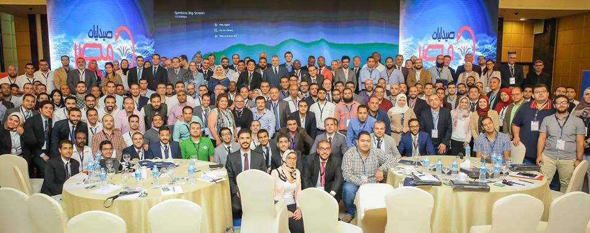

Conference and study tour
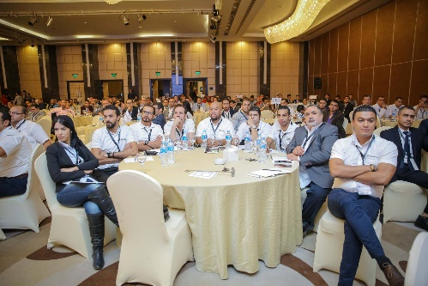

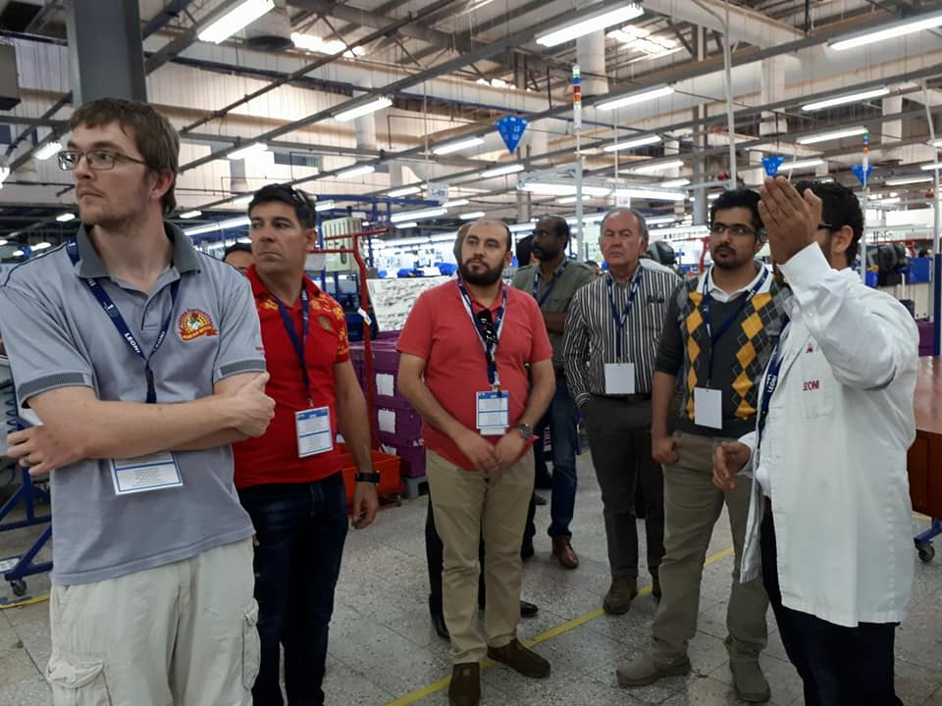

Fast Facts

68%
Of the participants in the conference participated in the study tour in the Factories
70%
Increase in the number of the participants than
Last year
40%
of the speakers from foreign countries

Participants in the conference:
10 companies participated in the conference with more than 320 participants from the companies
The companies included number of major companies in the field in which it included names
like: Oracle, Juhayna, Olam, Kapci, Misr Pharmacies,Lucram.
As well as 57357 Hospital as a Success partner.
Study Tour :
he study tour took place on 2 days in 3 major factories that implement the lean methodology.
These Factories are Bel, Leoni, and Kacpi.
With more than 100 participant in the study tour they were able to share their success stories and see how they are implementing the lean inside the factories
Media Coverage
Press releases:

For More Information
Please Visit our website: http://opexconference-mena.com
The conference has been covered by 11 newspapers which covered different aspects on the conference these are the newspapers that published news related to the conference:
تحيا مصر
جريدة الجمهورية
جريدة الفجر
جريدة الميزان
جريدة الاسبوع
جريدة المال
البوابة نيوز
الدستور
الفجر
TV Channels:
ONLIVE TV channel had several interviews with our speakers in the conference
Gallery
-The conference Videos link
-The conference photos link

